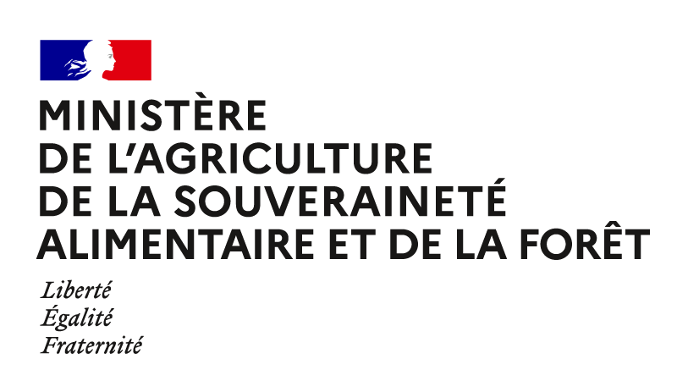Directorate General for Food

Highly Pathogenic Avian Influenza (HPAI)

situation in France

Updated 11th of October 2024

1. **Department with outbreak**

**One department currently has a restriction zone due to outbreaks: Finistère.**

**The farm was not vaccinated against HPAI. All the animals in the outbreaks were eliminated.**

**No outbreak in poultry has been confirmed since September, 30 2024.**

|  |  |  |  |
| --- | --- | --- | --- |
| **INFECTED DEPARTEMENTS** | Number of outbreaks | Date of outbreak (beginning of the outbreak) | Theoretical date of recovery of the free status |
| FINISTERE (29) | 1 | 29/09/2024 | 01/11/2024 |

**Control measures within the zoning**

As for all outbreaks, as soon as the suspicion was raised, control measures were triggered within the EU regulatory zoning (3 km Protection Zone “ZP” and 10 km Surveillance Zone “ZS” around the farm): culling of poultry on affected farms (at the latest the day after the national reference laboratory - NRL confirmation), reinforcement of biosecurity measures, census of farms and ban on poultry movements.

No other outbreak have been confirmed in poultry farming. This is an isolated event.

The contamination hypothesis for this outbreak is via wildlife.

1. **Free status recovery**

The Ille et Vilaine department (35) has recovered the HPAI-free status since September 19, 2024, and Morbihan since September 23, 2024.

|  |  |
| --- | --- |
| DEPARTEMENTS | Theoretical date of recovery of free status |
| FINISTERE (29) | **01/11/2024** |